How to Write a Summary
- Skim the piece. Don't take any notes this time -- just take in the bare minimum to wrap your mind around the basic plot of the book or article. You'll be able to concentrate on the smaller things later.
  - Think of the focus while you're reading. Get down the most basic of questions: Who? What? When? Where? Why? How? This bare bones thinking can help you to effectively and quickly write a pertinent summary.

- Read the piece thoroughly. In order to write an accurate summary, you must understand what you're reading. Try reading with the author's purpose in mind.
  - Take notes and highlight as you read. Take note of the subheadings, even if there aren't any. Dividing it into sections in your mind will help you organize your summary.
  - Consider why you have been assigned the text. Write down the author's main point and the main points of each section. Look for the writer's thesis and underline it. This is the main idea of the work.

- Outline the article. This serves as the skeleton of your summary. Write down the support points of each section, but do not go into minor detail.
  - It'll benefit you to write it in your own words now; that will save you time translating later. If you can't get around copying from the original, put quotation marks around it. Only do this with incredibly important sentences that cannot be reworded.^{[3]}

- Start with a clear identification of the work. This is the THESIS statement. This automatically lets your readers know your intentions and that you're covering the work of another author.
  - Clearly identify (in the present tense) the background information needed for your summary: the type of work, title, author, and main point. Example: In the featured article "Five Kinds of Learning," the author, Holland Oates, justifies his opinion on the hot topic of learning styles -- and adds a few himself.^{[3]}

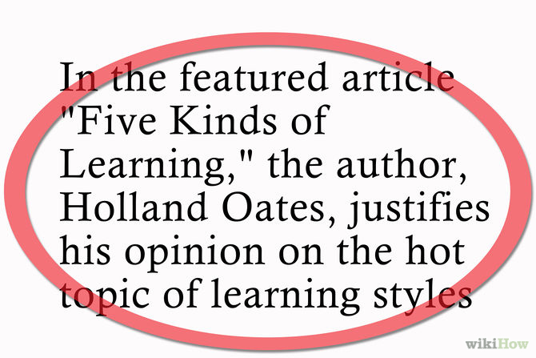

- Summarize the piece as a whole. Omit nothing important and strive for overall coherence through appropriate transitions. Write using "summarizing language." Your reader needs to be reminded that this is not your own work. Use phrases like the article claims, the author suggests, etc.^{[3]}
  - Present the material in a neutral fashion.^{[4]} Your opinions, ideas, and interpretations should be left in your brain -- don't put them into your summary. Be conscious of choosing your words. Only include what was in the original work.^{[3]}
  - Be concise. This is a summary -- it should be much shorter than the original piece. If you're working on an article, give yourself a target length of 1/4 the original article.

- Conclude with a final statement. This is not a statement of your own point of view, however; it should reflect the significance of the book or article from the author's standpoint.^{[2]}
  - Without rewriting the article, summarize what the author wanted to get across. Be careful not to evaluate in the conclusion or insert any of your own assumptions or opinions.

- Check for accuracy. A summary is slightly different than any other creative work -- you must maintain a voice that's current with the author's 100% of the time. Revisit the article as you go over your work -- are you jumping to any conclusions?
  - Does your summary make the same points as the article itself? Have you omitted anything important? Have you concentrated too much on the finer details?

- Ask someone else to read your work. Another person may see an argument or point in a completely different light than you have, giving you a new feel for the work and yours.
  - Not only should they be comparing your work for accuracy, ask them to read it for flow and summation. Can that person understand the sense of the article by reading your summary?^{[2]} Don't hesitate to ask for criticism; then weigh those criticisms and make valid changes.

- Revise your work. Now that you've monitored your work for accuracy and efficacy of tone and writing, make your small changes. Tweak the wording and transitions to make it as easy to read as possible.
  - Don't forget to look for spelling, grammar, and punctuation errors! Your credibility will seriously be questioned if you've glossed over the most basic of mistakes.
  - Submit your work -- before the deadline.

Adapted from Wikihow: How to Write a Summary

